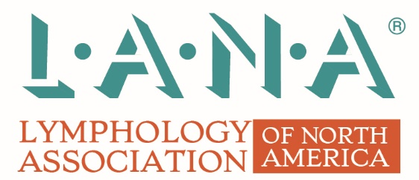

Introduction
The Lymphology Association of North America® (LANA®) provides a high-quality and vetted North American certification examination to certify healthcare professionals in the treatment of lymphedema. LANA® trademarks are important assets which must be used properly.
To preserve its reputation and protect its trademarks, LANA® diligently guards against any violation of its trademarks. LANA® acknowledges the desire of third parties to show affiliation with LANA®. Without written permission from LANA®, LANA®’s trademarks, service marks, or names used in a manner that suggests affiliation or association with LANA® is not permitted. Only parties with written permission from LANA® are allowed to use LANA® trademarks in accordance with applicable terms.
LANA® Trademarks
The following is list of LANA® North American and Canadian Trademarks which are subject to this policy and may not be used without prior written authorization. This list is subject to modification from time to time and anyone seeking to use any LANA® trademark or logo is advised to secure a current list when wanting to use such trademarks:
- LANA®
- Lymphology Association of North America®
- CLT-LANA®

Please review the following list of ways to avoid unauthorized use of LANA®’s trademarks:
• Do not use a LANA® trademark or name in a manner that is likely to cause confusion about the origin of any product, service material, course, technology, program, or other offerings.
• Without prior permission from LANA®, do not use a LANA® trademark or name in a manner that is likely to give the impression or otherwise imply an affiliation or association between products or services and LANA®, or any of its products, services, programs, materials, or other offerings.
• Do not use any of the LANA® logos in materials without the written permission of LANA®.
• Do not use any LANA® trademark or name as or as part of a company, product, service, solution, technology, or program name.
• Do not use a LANA® trademark or name in a manner that is likely to dilute, defame, disparage, harm the reputation, or depreciate the goodwill of LANA®.
• Do not use any trademark, name, or designation that is confusingly similar to the LANA® name or any LANA® trademark.
• Do not copy or imitate any LANA® type style, logo, product packaging, or the look, design, or overall commercial impression of any LANA® website, social media, or other materials.
• Do not register or use any domain name that consists of or incorporates any LANA® mark or name.
• Do not register or seek to register a LANA® trademark or name or any mark or name that is confusingly similar to a LANA® mark or name.
- Do not modify any LANA® logo.

Uses of LANA®’s trademarks
Any commercial use of the LANA® trademarks must first be approved by the Lymphology Association of North America®. In general, we will approve the use of LANA®, the name Lymphology Association of North America®, and/or CLT-LANA® logos when referring to our certification examination for lymphedema treatment providers. Any approved materials that use the marks Lymphology Association of North America®, LANA®, CLT-LANA®, or the unaltered logos also will be required to include a notice that the particular mark(s) being used “is/are a registered trademark of the Lymphology Association of North America®, and is/are being used with permission”.
Nominative use involving accurate statements that a training program meets the LANA® minimal educational training requirements without implying sponsorship or other relationship with The Lymphology Association of North America® -- by stating: “The 135 hour training program provided by _(insert name of training program)_ meets minimum LANA® training requirements” -- is permissible and does not require our prior approval.
The professional designation CLT-LANA® may only be used by healthcare professionals who hold a valid LANA certification.
Impermissible Uses
Proposed uses, including calling a training program a “LANA® training program” or “LANA® Preparation course” or “LANA® approved…”, are impermissible and will be refused.
We also will NOT permit any of LANA®’s trademarks to be used:
- to refer to any other certification examination;
- in a way that is misleading or may imply association of unrelated examinations, or training programs;
- in ways that confuse the community as to whether LANA® approves, endorses, or promotes one training program over another where both meet LANA® prerequisites; and/or
- in a manner that implies a training program can be completed in less than the prerequisites set forth by LANA®.

